Rodsley & Yeaveley Parish Council

Annual General Meeting

To be held at

Wyaston Village Hall

On Wednesday 3rd May 2017 at 7.30 pm

Dear Councillors,

Please attend the AGM of Rodsley & Yeaveley Parish Council which is to be held at Wyaston Village Hall on Wednesday 3rd May 2017 at 7.30 pm.

Yours sincerely
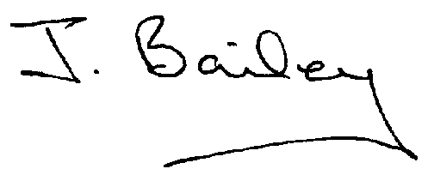
J Bailey (Clerk

Agenda

- Apologies
- Minutes of the last AGM
- Election of Chair
- Election of Vice Chair
5. Financial transactions agreed and signed as per audit requirements.
6 Review of Standing Orders
7. Review of Code of Conduct
8. Inventory of assets
9. Review of Insurance
10. Land Title No DY227190

