Rodsley & Yeaveley Parish Council
Dear Councillors,
You are summoned to attend the meeting of Rodsley & Yeaveley Parish Council to be held on Wednesday 12th July 2017 at Wyaston Village Hall.
Members are asked to complete the Declarations sheet (if appropriate) provided at the meeting.
Yours sincerely

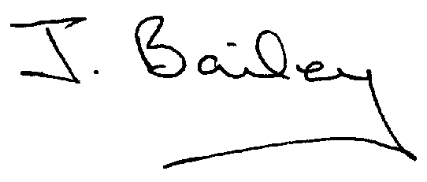Agenda
- Apologies
- Declaration of Members Interests.
  - Members must ensure that they complete the Declarations of Interest Sheet prior to the start of the meeting and must indicate the action to be taken (i.e. to stay in the meeting, to leave the meeting or to stay in the meeting to make representations and then leave the meeting prior to any consideration or determination of the item)
  - Where a Member indicates that they have a prejudicial interest, but wish to make representations regarding the item before leaving the meeting, those representations must be made under the item Public Participation
The Declarations of Interests will be read out from the Declaration Sheet – Members will be asked to confirm that the record is correct.
- Public Participation. This is for maximum 30 minutes – no person to speak for more than 5 minutes.
- Minutes of the Last Meeting
- Neighbourhood Watch
- Planning Application, Mushroom Farm, Yeaveley, Construction of 9 dwellings and Associated Open Space and Footpath 12
- Planning Application, The Hollies, Rodsley, Demolition of Conservatory and Construction of 2-Storey Extension
- Planning Application, Polperro, Yeaveley, canopy Extension, External Alterations and Fence.
- Planning Application, French Horn Cottage, erection of Storage Shed and Workshop and Incorporation of land into Domestic Curtilage.
- Planning Application, Sunnymead, Hales Green, 2 Storey Side and Rear Extension.
- Planning Application, Ash Tree Farm, Rodsley Extension to Livestock Store.
- Planning Application, Swallowtail Farm, Yeaveley, 2-storey Rear Extension and Demolition of Outbuilding.
- Footpath Issues.
- Highways Issues
- Flooding Issues
- Yeaveley Notice Board
- Clerk’s Report
- Financial Matters
- Date of the Next Meeting.

