Leapley Lane
Yeaveley
DE6 2DU

Rodsley & Yeaveley Parish Council
Dear Councillors,
You are summoned to attend the meeting of Rodsley & Yeaveley Parish Council to be held on Tuesday 1st March 2016 at 7.30 at Wyaston Village Hall.
Members are asked to complete the Declarations sheet (if appropriate) provided at the meeting.
Yours sincerely
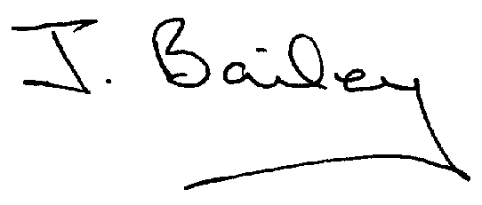Agenda
- Apologies
- Declaration of Members Interests.

Please Note:-
  - Members must ensure that they complete the Declarations of Interest Sheet prior to the start of the meeting and must indicate the action to be taken (i.e. to stay in the meeting, to leave the meeting or to stay in the meeting to make representations and then leave the meeting prior to any consideration or determination of the item)
  - Where a Member indicates that they have a prejudicial interest, but wish to make representations regarding the item before leaving the meeting, those representations must be made under the item Public Participation
The Declarations of Interests will be read out from the Declaration Sheet – Members will be asked to confirm that the record is correct.

- Public Participation.
- Minutes of the Last Meeting
- Neighbourhood Watch
- Consultation on Planning Applications
- Planning Application, Demolition of Yeaveley Arms and Erection of 4 dwellings.
- Planning Application, Honeysuckle Farm, Rodsley, Partial Change of Use to Boarding Kennels
- Planning Application, The Westings, Change of Use of Land to the rear of The Old School House from Agricultural to domestic.
10.Discharge of S106M planning obligation dated 2nd October 1990 to change occupancy restriction - 6 Gravelly Bank Mews, Yeaveley.
11.Transparency Fund for Smaller Authorities
12.Local Flooding Issues
13.Highways Issues
14.Auditing Procedures for Smaller Authorities.
15 Request for Village Plan to be put back in the Information Kiosk
16. Update on Airways
17 Volunteering Opportunities
18. DCC consulting to withdraw funding for subsidised local bus services and community transport Dial-a-Bus ‘shopping buses’ from October 2017.
19.Clerk’s Report
20.Financial Matters
21.Date of the Next Meeting

