Leapley Lane
Yeaveley
DE6 2DU

Rodsley & Yeaveley Parish Council
Dear Councillors,
You are summoned to attend the meeting of Rodsley & Yeaveley Parish Council to be held on Monday March 6th 2017 at 7.30 at Wyaston Village Hall.
Members are asked to complete the Declarations sheet (if appropriate) provided at the meeting.
Yours sincerely

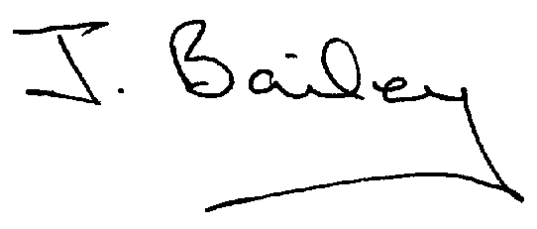Agenda
- Apologies
- Declaration of Members Interests.
  - Members must ensure that they complete the Declarations of Interest Sheet prior to the start of the meeting and must indicate the action to be taken (i.e. to stay in the meeting, to leave the meeting or to stay in the meeting to make representations and then leave the meeting prior to any consideration or determination of the item)
  - Where a Member indicates that they have a prejudicial interest, but wish to make representations regarding the item before leaving the meeting, those representations must be made under the item Public Participation
The Declarations of Interests will be read out from the Declaration Sheet – Members will be asked to confirm that the record is correct.
- Public Participation.
- Minutes of the Last Meeting
- Neighbourhood Watch
- Planning Application, Mushroom Farm, Yeaveley, Construction of 9 dwellings and Associated Open Space
- Planning Application, Demolition of Conservatory and Outbuilding and Erection of 2 Storey Extension to the Rear and Porch to the Front, Swallowtail Farm, Yeaveley.
- Planning Application, Single and 2-Storey Rear Extension, French Horn Cottage, Rodsley Lane, Rodsley.
- Planning Application, Demolition of Shed and Erection of 3 Garages, Three Pots, Rodsley Lane, Yeaveley
- Planning Application, Erection of Agricultural Storage Building off Rodsley Lane, Rodlsey.
- Planning Application Single Storey Extension and Dormer to Rear, Park View, Park Lane, Rodsley.
- Footpath 12
- Highways Issues
- Flooding Issues
- Yeaveley Notice Board
- Clerk’s Report
- Financial Matters
- Date of the Next Meeting.

