Rodsley & Yeaveley Parish Council
Dear Councillors,
You are summoned to attend the meeting of Rodsley & Yeaveley Parish Council to be held on Monday 6th November at 7.30 at 2017 at Wyaston Village Hall.
Members are asked to complete the Declarations sheet (if appropriate) provided at the meeting.
Yours sincerely

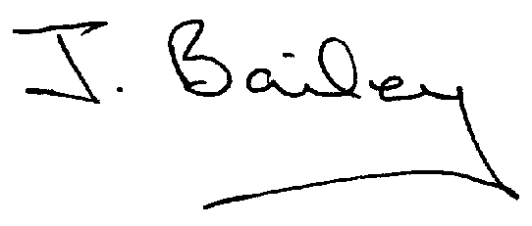Agenda
- Apologies
- Declaration of Members Interests.
  - Members must ensure that they complete the Declarations of Interest Sheet prior to the start of the meeting and must indicate the action to be taken (i.e. to stay in the meeting, to leave the meeting or to stay in the meeting to make representations and then leave the meeting prior to any consideration or determination of the item)
  - Where a Member indicates that they have a prejudicial interest, but wish to make representations regarding the item before leaving the meeting, those representations must be made under the item Public Participation
The Declarations of Interests will be read out from the Declaration Sheet – Members will be asked to confirm that the record is correct.

- Public Participation. This is for maximum 30 minutes – no person to speak for more than 5 minutes.
- Minutes of the Last Meeting
- Neighbourhood Watch
- Planning Application, Mushroom Farm, Yeaveley, Construction of 9 dwellings and Associated Open Space and Footpath 12
- Planning Application, Oak Trees, Park Lane.
- Planning Application, Tulubardine, Rodsley Lane, Yeaveley
- Planning Application, Southleigh 6, Rodsley Lane, Yeaveley
- Planning Application Stydd Hall Farm, Darley Moor.
- Footpath Issues
- Highways Issues
- Flooding Issues
- General Data Protection Regulations
- Councillor Training
- Winter Service
- Precept for 2018/2019
- Clerk’s Report
- Financial Matters
- Date of the Next Meeting.

