Rodsley & Yeaveley Parish Council

Extraordinary Meeting
Dear Residents,
You are invited to attend the Extraordinary meeting of Rodsley & Yeaveley Parish Council to be held on Monday November 21st 2016 at 6.30 in Yeaveley Church.
Members are asked to complete the Declarations sheet (if appropriate) provided at the meeting.
Yours sincerely

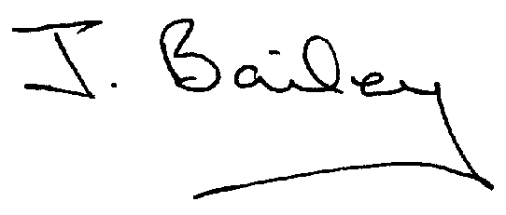Agenda
- Apologies
- Declaration of Members Interests.
  - Members must ensure that they complete the Declarations of Interest Sheet prior to the start of the meeting and must indicate the action to be taken (i.e. to stay in the meeting, to leave the meeting or to stay in the meeting to make representations and then leave the meeting prior to any consideration or determination of the item)
  - Where a Member indicates that they have a prejudicial interest, but wish to make representations regarding the item before leaving the meeting, those representations must be made under the item Public Participation
The Declarations of Interests will be read out from the Declaration Sheet – Members will be asked to confirm that the record is correct.
- Public Participation.

- Planning Application, Change of Use of Agricultural Building to Dwelling House (Use Class C3) and Associated Building Operations, Land to West of Corner Farm, Rodsley Lane, Rodsley.

