Leapley Lane
Yeaveley
DE6 2DU

Rodsley & Yeaveley Parish Council
Dear Councillors,
You are summoned to attend the meeting of Rodsley & Yeaveley Parish Council to be held on Tuesday July 5th 2016 at 7.30 at Wyaston Village Hall.
Members are asked to complete the Declarations sheet (if appropriate) provided at the meeting.
Yours sincerely

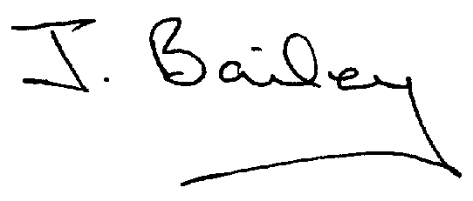Agenda
- Apologies
- Declaration of Members Interests.
  - Members must ensure that they complete the Declarations of Interest Sheet prior to the start of the meeting and must indicate the action to be taken (i.e. to stay in the meeting, to leave the meeting or to stay in the meeting to make representations and then leave the meeting prior to any consideration or determination of the item)
  - Where a Member indicates that they have a prejudicial interest, but wish to make representations regarding the item before leaving the meeting, those representations must be made under the item Public Participation
The Declarations of Interests will be read out from the Declaration Sheet – Members will be asked to confirm that the record is correct.
- Public Participation.
- Minutes of the Last Meeting
- Neighbourhood Watch
- Consultation on Planning Applications
- Planning Application, Demolition of Yeaveley Arms and Erection of 4 dwellings.
- Should the Council Apply to have the Yeaveley Arms made a Community Asset.
- Planning Application, Erection of replacement garage with ancilliary accommodation over at Hillcrest, Park Lane, Rodsley
- Planning Application, First Floor Extension above Living Room to Unit 1, The Priory, Rodsley Lane, Yeaveley.
- Planning Application, The Park, Wyaston Road, Yeaveley, Single storey extension and alterations.
- Application for Certificate of Lawful Proposed Development – Use of Holiday Accommodation as 2 Independent Dwellings, The Park, Wyaston Road, Yeaveley.
- Planning Application, Erection of Detached Garage and Store with Office Space Above, Swallow Tail Farm, Wyaston Road, Yeaveley.
- Planning Application, Stydd Hall, Darley Moor, Removal of Modern Window Frame and Installation of New Stone Mullioned Window Surround and Window Frames to Pantry.
- Issues re non-maintained land.
- Highways Issues – including residents request for a pavement at the corner of Priory Close
- Flooding Issues
- Rodsley Notice Board Repairs.
- £1,000 Discretionary Fund
- Application for Transparency Fund 2016/17
- Clerk’s Report
- Financial Matters
- Date of the Next Meeting

