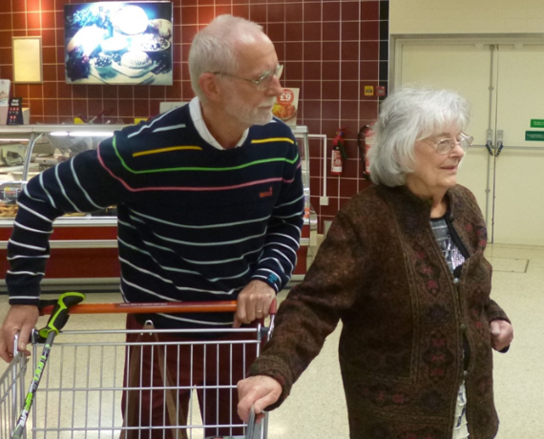

Befriending, shopping, practical help, short term wheelchair hire, transport to cancer related appointments.

Have you got some time to give? We need volunteers to help support people in their local community.

Contact us for further information on 01335-348600.
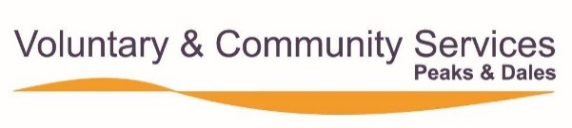
Registered Charity Number 1067193.

