Leapley Lane
Yeaveley
DE6 2DU

Rodsley & Yeaveley Parish Council
Dear Councillors,
You are summoned to attend the meeting of Rodsley & Yeaveley Parish Council to be held on Tuesday 10th May 2016 at approximately 7.45, following the AGM, at Wyaston Village Hall.
Members are asked to complete the Declarations sheet (if appropriate) provided at the meeting.
Yours sincerely
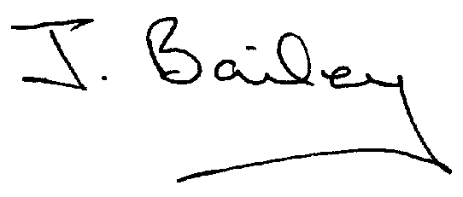Agenda
- Apologies
- Declaration of Members Interests.

Please Note:-
  - Members must ensure that they complete the Declarations of Interest Sheet prior to the start of the meeting and must indicate the action to be taken (i.e. to stay in the meeting, to leave the meeting or to stay in the meeting to make representations and then leave the meeting prior to any consideration or determination of the item)
  - Where a Member indicates that they have a prejudicial interest, but wish to make representations regarding the item before leaving the meeting, those representations must be made under the item Public Participation
The Declarations of Interests will be read out from the Declaration Sheet – Members will be asked to confirm that the record is correct.

- Public Participation.
- Minutes of the Last Four Meetings
- Neighbourhood Watch
- Consultation on Planning Applications
- Planning Application, Demolition of Yeaveley Arms and Erection of 4 dwellings.
- Planning Application, Erection of Workshop and Store, The Priory, Rodsley Lane, Yeaveley.
- Planning Application, First Floor Extension above Living Room to Unit 1, The Priory, Rodsley Lane, Yeaveley.
- Auditing Procedures for Smaller Authorities.
- Discuss the Annual Governance Statement for the Annual Audit of Accounts.
- Highways Issues – including residents request for a pavement at the corner of Priory Close and Greensides effluent waste disposal onto highway and local watercourses.
- Flooding Issues
- Rodsley Notice Board Repairs.
- £1,000 Discretionary Fund available – Possible use for a chemical toilet to be placed in the churchyard or waste bin to be placed near the bus shelter in Yeaveley.
- Application for Transparency Fund 2016/17
- Clerk’s Report
- Financial Matters
- Date of the Next Meeting

