Leapley Lane
Yeaveley
DE6 2DU

Rodsley & Yeaveley Parish Council
Dear Councillors,
You are summoned to attend the meeting of Rodsley & Yeaveley Parish Council to be held on Tuesday November 1st 2016 at 7.30 at Wyaston Village Hall.
Members are asked to complete the Declarations sheet (if appropriate) provided at the meeting.
Yours sincerely

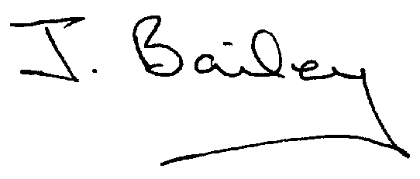Agenda
- Apologies
- Declaration of Members Interests.
  - Members must ensure that they complete the Declarations of Interest Sheet prior to the start of the meeting and must indicate the action to be taken (i.e. to stay in the meeting, to leave the meeting or to stay in the meeting to make representations and then leave the meeting prior to any consideration or determination of the item)
  - Where a Member indicates that they have a prejudicial interest, but wish to make representations regarding the item before leaving the meeting, those representations must be made under the item Public Participation
The Declarations of Interests will be read out from the Declaration Sheet – Members will be asked to confirm that the record is correct.
- Public Participation.
- Co-option of New Councillor
- Minutes of the Last Meeting
- Neighbourhood Watch
- Report, Committee re: Application for Yeaveley Arms to be made a Community Asset.
- Planning App., The Park, Wyaston Road, Yeaveley, Single storey extension.
- Planning Application, Stydd Hall, Agricultural Worker’s Dwelling
- Planning Application, Mushroom Farm, Yeaveley, Construction of 9 dwellings and Associated Open Space
- Planning Application, Erection of Stable Building at Greenacres, Shirley Lane Rodsley.
- Footpath 12 and 13.
- Highways Issues
- Flooding Issues
- £1,000 Discretionary Fund
- Clerk’s Report
- Clerk’s Appraisal
- Financial Matters
- Date of the Next Meeting

