Leapley Lane
Yeaveley
DE6 2DU

Rodsley & Yeaveley Parish Council
Dear Councillors,
You are summoned to attend the meeting of Rodsley & Yeaveley Parish Council to be held on Tuesday September 6th 2016 at 7.30 at Wyaston Village Hall.
Members are asked to complete the Declarations sheet (if appropriate) provided at the meeting.
Yours sincerely

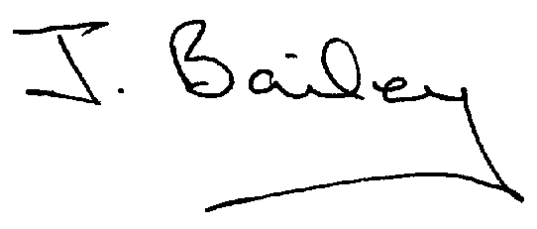Agenda
- Apologies
- Declaration of Members Interests.
  - Members must ensure that they complete the Declarations of Interest Sheet prior to the start of the meeting and must indicate the action to be taken (i.e. to stay in the meeting, to leave the meeting or to stay in the meeting to make representations and then leave the meeting prior to any consideration or determination of the item)
  - Where a Member indicates that they have a prejudicial interest, but wish to make representations regarding the item before leaving the meeting, those representations must be made under the item Public Participation
The Declarations of Interests will be read out from the Declaration Sheet – Members will be asked to confirm that the record is correct.
- Public Participation.
- Minutes of the Last Meeting
- Neighbourhood Watch
- Report, Committee re: Application for Yeaveley Arms to be made a Community Asset.
- Planning App., Erection of replacement garage with ancillary accommodation over at Hillcrest, Park Lane, Rodsley
- Planning App., The Park, Wyaston Road, Yeaveley, Single storey extension.
- Application for Certificate of Lawful Proposed Development – Use of Holiday Accommodation as 2 Independent Dwellings, The Park, Wyaston Road, Yeaveley.
- Planning Application, Erection of Detached Garage and Store with Office Space Above, Swallow Tail Farm, Wyaston Road, Yeaveley.
- Planning Application, Stydd Hall, Darley Moor, Removal of Modern Window Frame and Installation of New Stone Mullioned Window Surround and Window Frames to Pantry.
- Planning Application, Stydd Hall, Agricultural Worker’s Dwelling
- Planning Application, Mushroom Frm, Yeaveley, Construction of 9 dwellings and Associated Open Space
- Highways Issues
- Flooding Issues
- £1,000 Discretionary Fund
- Ombudsman’s Microlite Ruling at the Airfield Darley Moor
- Casual Vacancy
- Clerk’s Report
- Financial Matters
- Date of the Next Meeting

