J Bailey (Clerk)
Hellingly House
Leapley Lane
Yeaveley
DE6 2DU

Rodsley & Yeaveley Parish Council
Dear Councillors,

You are summoned to attend the meeting of Rodsley & Yeaveley Parish Council to be held at 8.00pm on Thursday July 17th 2014 at Wyaston Village Hall.
Members are asked to complete the Declarations sheet (if appropriate) provided at the meeting.
Yours sincerely
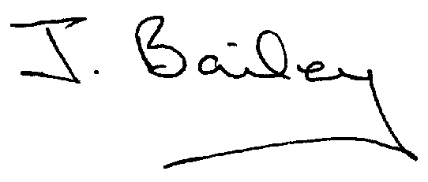Agenda
- Apologies
- Declaration of Members Interests.

Please Note:-
  - Members must ensure that they complete the Declarations of Interest Sheet prior to the start of the meeting and must indicate the action to be taken (i.e. to stay in the meeting, to leave the meeting or to stay in the meeting to make representations and then leave the meeting prior to any consideration or determination of the item)
  - Where a Member indicates that they have a prejudicial interest, but wish to make representations regarding the item before leaving the meeting, those representations must be made under the item Public Participation
The Declarations of Interests will be read out from the Declaration Sheet – Members will be asked to confirm that the record is correct.

- Public Participation.
- Election/Co-option of a New Councillor
- Minutes of the last meeting
- Neighbourhood Watch
- Planning Application, erection of Agricultural Worker’s Dwelling, Park House, Yeaveley
- Planning Application, Alterations to listed building, Stydd Hall, Darley Moor
- Local Flooding Issues
- Highways Issues
- Traffic Assessment
- Shirley Village Parish Plan
- Defibrillator in the Information Centre (Old BT Kiosk)?
- Social Event.
- Report on Footpath Workshop
- Rural Housing Policy Review
- Rodsley Bus Shelter
- Clerk’s Report
- Financial Matters
- Date of the Next Meeting

