J Bailey (Clerk)
Hellingly House
Leapley Lane
Yeaveley
DE6 2DU

Rodsley & Yeaveley Parish Council
Dear Councillors,

You are summoned to attend the meeting of Rodsley & Yeaveley Parish Council to be held at 7.30 at Wyaston Village Hall on Tuesday 4th March 2014.
Members are asked to complete the Declarations sheet (if appropriate) provided at the meeting.
Yours sincerely
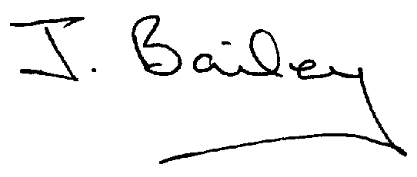Agenda
- Apologies
- Declaration of Members Interests.

Please Note:-
  - Members must ensure that they complete the Declarations of Interest Sheet prior to the start of the meeting and must indicate the action to be taken (i.e. to stay in the meeting, to leave the meeting or to stay in the meeting to make representations and then leave the meeting prior to any consideration or determination of the item)
  - Where a Member indicates that they have a prejudicial interest, but wish to make representations regarding the item before leaving the meeting, those representations must be made under the item Public Participation
The Declarations of Interests will be read out from the Declaration Sheet – Members will be asked to confirm that the record is correct.

- Public Participation.
- Minutes of the last meeting
- Neighbourhood Watch
- Planning Application, erection of Agricultural Worker’s Dwelling, Park House, Yeaveley
- Planning Application, Replacement of Existing Windows, Rodsley House, Rodsley
- Planning Application, Erection of two storey extension, Hillcrest, Park Lane, Rodsley
- Planning Application, Alterations to listed building, Stydd Hall, Darley Moor
- Appeal against Planning Application granted in 2013 to Spring Cottage, Rodsley
- Planning Application, Extension to existing Hay/storage Shed, Finney Butts Barn, Rodsley
- Planning Application, First Floor Extension, The Heathers, Leapley Lane, Yeaveley
- Planning Application, Change of Use, Mushroom Farm, Yeaveley
- Local Flooding Issues
- Highways Issues
- Shirley Village Parish Plan
- Shirley Village Community Centre
- Defibrillator in the Information Centre (Old BT Kiosk)?
- Model Standing Orders Amendments
- Clerk’s Report
- Financial Matters
- Dates for the Annual Village Meetings
- Date of the Next Meeting

