J Bailey (Clerk)
Hellingly House
Leapley Lane
Yeaveley
DE6 2DU

Rodsley & Yeaveley Parish Council
Dear councillors,

You are summoned to attend the meeting of Rodsley & Yeaveley Parish Council to be held on Tuesday November 4th 2014 at 7.30 at Wyaston Village Hall.
Members are asked to complete the Declarations sheet (if appropriate) provided at the meeting.
Yours sincerely
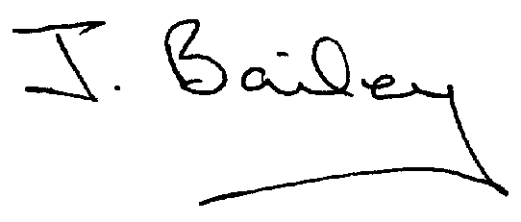Agenda
- Apologies
- Declaration of Members Interests.

Please Note:-
  - Members must ensure that they complete the Declarations of Interest Sheet prior to the start of the meeting and must indicate the action to be taken (i.e. to stay in the meeting, to leave the meeting or to stay in the meeting to make representations and then leave the meeting prior to any consideration or determination of the item)
  - Where a Member indicates that they have a prejudicial interest, but wish to make representations regarding the item before leaving the meeting, those representations must be made under the item Public Participation
The Declarations of Interests will be read out from the Declaration Sheet – Members will be asked to confirm that the record is correct.

- Public Participation.
- Minutes of the Last Meeting
- Neighbourhood Watch
- Planning Application, Erection of Agricultural Worker’s Dwelling, Park House, Yeaveley
- Planning Application, Single/two Storey Extensions, Ivy House Farm, Yeaveley
- Planning Laws re New Entrances to Property/Fields.
- Derbyshire Dales Local Plan
- Rodsley Bus Shelter
- Local Flooding Issues
- Highways Issues
- Snow Warden Scheme
- Defibrillator
- How to Report Noise Disturbance and Untidy Neighbours
- Rural Open Sure Signal, Vodafone
- Clerk’s Report
- Clerk’s Appraisal
- Automatic Enrolment Employee Pension Scheme
- Precept 2015/2016
- Financial Matters
- Date of the Next Meeting

