Hellingly House
Leapley Lane
Yeaveley
DE6 2DU

Rodsley & Yeaveley Parish Council
Dear Residents,

You are summoned to attend the Extraordinary Meeting of Rodsley & Yeaveley Parish Council to be held on Monday April 27th 2015 at 6.30 at Yeaveley Church.
Members are asked to complete the Declarations sheet (if appropriate) provided at the meeting.
Yours sincerely
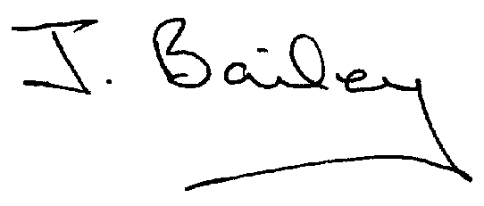Agenda
- Apologies
- Declaration of Members Interests.

Please Note:-
  - Members must ensure that they complete the Declarations of Interest Sheet prior to the start of the meeting and must indicate the action to be taken (i.e. to stay in the meeting, to leave the meeting or to stay in the meeting to make representations and then leave the meeting prior to any consideration or determination of the item)
  - Where a Member indicates that they have a prejudicial interest, but wish to make representations regarding the item before leaving the meeting, those representations must be made under the item Public Participation
The Declarations of Interests will be read out from the Declaration Sheet – Members will be asked to confirm that the record is correct.

- Public Participation.

4. Planning Application Erection of Agricultural Machinery Store, Shedley Manor, Rodsley Lane, Yeaveley.

