Leapley Lane
Yeaveley
DE6 2DU

Rodsley & Yeaveley Parish Council
Dear Councillors,
You are summoned to attend the meeting of Rodsley & Yeaveley Parish Council to be held on Tuesday 3rd November 2015 at 7.30 at Wyaston Village Hall.
Members are asked to complete the Declarations sheet (if appropriate) provided at the meeting.
Yours sincerely
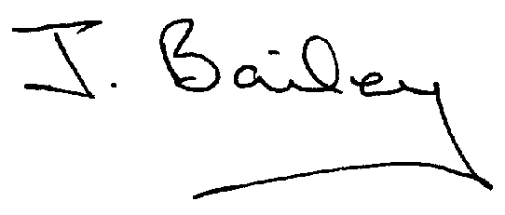Agenda
- Apologies
- Declaration of Members Interests.

Please Note:-
  - Members must ensure that they complete the Declarations of Interest Sheet prior to the start of the meeting and must indicate the action to be taken (i.e. to stay in the meeting, to leave the meeting or to stay in the meeting to make representations and then leave the meeting prior to any consideration or determination of the item)
  - Where a Member indicates that they have a prejudicial interest, but wish to make representations regarding the item before leaving the meeting, those representations must be made under the item Public Participation
The Declarations of Interests will be read out from the Declaration Sheet – Members will be asked to confirm that the record is correct.

- Public Participation.
- Minutes of the Last Meeting
- Neighbourhood Watch
- Planning Application, Demolition of Yeaveley Arms and Erection of 4 dwellings.
- Planning Application, Honeysuckle Farm, Rodsley, Partial Change of Use to Boarding Kennels
- Planning Application, Honeysuckle Farm, Rodsley, temporary mobile home for 3 more years.
- Planning Application, The Old School, Yeaveley, Porch Extension
- Planning Application, Corner Close, Rodsley.
- Planning Application, The Priory, Yeaveley.
- Planning Application, Outline, Mushroom Farm, Rodsley Lane, Yeaveley
- Possible Change of Use of Land to the rear of The Old School House.
- Website for Parish Council, (Transparency Code for smaller Authorities)
- Local Flooding Issues
- Highways Issues
- Further first aid training
- Clarification of Issues Raised about the Airfield, Darley Moor.
- Footpath and Bridle Way Maintenance
- Clerk’s Report
- Financial Matters
- Date of the Next Meeting

