Rodsley & Yeaveley Parish Council
Dear Residents,
You are invited to attend the meeting of Rodsley & Yeaveley Parish Council to be held on Sunday 5th August 2018 at 7.30 in The Yeaveley Arms
Members are asked to complete the Declarations sheet (if appropriate) provided at the meeting.
Yours sincerely

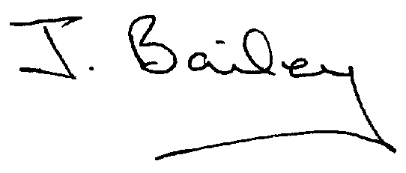Agenda
- Apologies
- Declaration of Members Interests.
  - Members must ensure that they complete the Declarations of Interest Sheet prior to the start of the meeting and must indicate the action to be taken (i.e. to stay in the meeting, to leave the meeting or to stay in the meeting to make representations and then leave the meeting prior to any consideration or determination of the item)
  - Where a Member indicates that they have a prejudicial interest, but wish to make representations regarding the item before leaving the meeting, those representations must be made under the item Public Participation
The Declarations of Interests will be read out from the Declaration Sheet – Members will be asked to confirm that the record is correct.

- Public Participation. This is for maximum 30 minutes – no person to speak for more than 5 minutes.
- Minutes of the Last Meeting
- Neighbourhood Watch
- Change of Website Provider.
- Planning Application, The Beeches Rodsley Lane, Yeaveley
- Planning Application, 10,Priory Close, Yeaveley
- Planning Application, Southleigh 6, Rodsley Lane, Yeaveley
- Planning Application, 12 Priory Close, Yeaveley.
- Planning Application, 3 Holiday Cabins off Rodsley Lane Yeaveley.
- Honeysuckle Farm, Noise Level Issues.
- Complaint of Dog Incident by Parish Resident
- Footpath Issues
- Highways Issues
- Flooding Issues
- Rural Broadband Issues
- Clerk’s Report
- Financial Matters
- Date of the Next Meeting.

