Rodsley & Yeaveley Parish Council
Dear Councillors,
You are summoned to attend the meeting of Rodsley & Yeaveley Parish Council to be held on Monday 21st May 1018 immediately following the Annual Meeting in The Yeaveley Arms
Members are asked to complete the Declarations sheet (if appropriate) provided at the meeting.
Yours sincerely

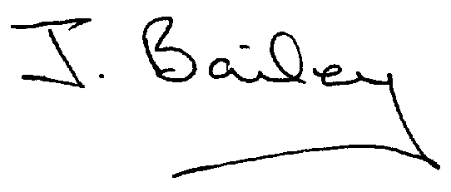Agenda
- Apologies
- Declaration of Members Interests.
  - Members must ensure that they complete the Declarations of Interest Sheet prior to the start of the meeting and must indicate the action to be taken (i.e. to stay in the meeting, to leave the meeting or to stay in the meeting to make representations and then leave the meeting prior to any consideration or determination of the item)
  - Where a Member indicates that they have a prejudicial interest, but wish to make representations regarding the item before leaving the meeting, those representations must be made under the item Public Participation
The Declarations of Interests will be read out from the Declaration Sheet – Members will be asked to confirm that the record is correct.

- Public Participation. This is for maximum 30 minutes – no person to speak for more than 5 minutes.
- Minutes of the Last Meeting
- Neighbourhood Watch
- Change of Website Provider.
- Planning Application, The Beeches Rodsley Lane, Yeaveley
- Planning Application, 1,Primrose Bank, Leapley Lane, Yeaveley
- Planning Application, 10,Priory Close, Yeaveley
- Planning Application, Southleigh 6, Rodsley Lane, Yeaveley
- Planning Application, 12 Priory Close, Yeaveley
- Planning Application, Honeysuckle Farm, Rodsley
- Planning Application, Oak Tree, Park Lane
- Planning Requirement Contravened, Spring Cottage, Rodsley
- Footpath Issues
- Highways Issues, with particular reference to Cycle route 68 and Rodsley Lane flooding.
- Flooding Issues
- Rural Broadband Issues
- Clerk’s Report – including GDPR Training.
- Financial Matters
- Date of the Next Meeting.

