Rodsley & Yeaveley Parish Council

Annual Meeting

To be held at

The Yeaveley Arms

On Monday May 21st 2018 at 7.30 pm

Dear Councillors,

Please attend the Annual Meeting of Rodsley & Yeaveley Parish Council which is to be held at The Yeaveley Arms on Monday May 21st at 7.30 pm.

Yours sincerely
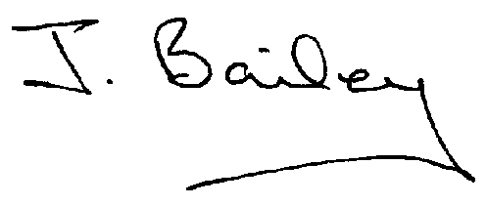
J Bailey (Clerk

Agenda

- Apologies
- Minutes of the last AGM
- Election of Chair
- Election of Vice Chair
- Equal Opportunities Policy for Parish Council
- Review of Financial Regulations
- Approval of Certificate of Exemption
- Approval of Annual Governance Statement
- Approval of Accounting Statement.
6 Review of Standing Orders
7. Review of Code of Conduct
8. Inventory of assets
9. Review of Insurance
10. Land Title No DY227190

