Rodsley & Yeaveley Parish Council
Dear Councillors,
You are summoned to attend the meeting of Rodsley & Yeaveley Parish Council to be held on Sunday 24th March 2019at 7.30 in The Yeaveley Arms.
Members are asked to complete the Declarations sheet (if appropriate) provided at the meeting.
Yours sincerely

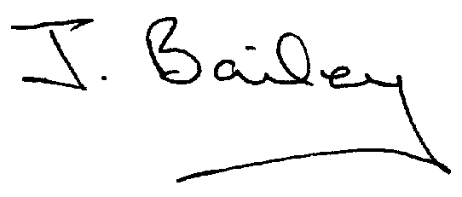Agenda
- Apologies
- Declaration of Members Interests.
  - Members must ensure that they complete the Declarations of Interest Sheet prior to the start of the meeting and must indicate the action to be taken (i.e. to stay in the meeting, to leave the meeting or to stay in the meeting to make representations and then leave the meeting prior to any consideration or determination of the item)
  - Where a Member indicates that they have a prejudicial interest, but wish to make representations regarding the item before leaving the meeting, those representations must be made under the item Public Participation
The Declarations of Interests will be read out from the Declaration Sheet – Members will be asked to confirm that the record is correct.

- Public Participation. This is for maximum 30 minutes – no person to speak for more than 5 minutes.
- Minutes of the Last Meeting
- Neighbourhood Watch
- Planning Application, Stydd Hall Farm, Agricultural Worker’s Dwelling.
- Honeysuckle Farm, Noise Level Issues, now subject of DCOND.
- Honeysuckle Farm, Proposed Agricultural Worker’s Dwelling
- Planning Application, 2-Storey and Single Storey Extentions and Detached Garage at The Cottage, Hales Green.
- Planning Application, Two Storey Side Extension, The Firs, Rodsley Lane, Yeaveley
- Planning Application, Erection of Agricultural Livestock and Storage Building, Land, Shirley Lane, Rodsley.
- Planning Application, 2-Storey Side Extension, The Firs, Rodsley Lane, Yeaveley
- Planning Application, 3 Dwellings on Land to the Rear of 12, Priory Close, Yeaveley
- Planning Application, Erection of Dwelling, Land at Cross Roads, Rodsley.
- Planning Enforcement Complaint
- Parish Council Elections
- Dates for the Village Meetings
- Footpath Issues
- Highways Issues
- Flooding Issues
- Clerk’s Report
- Financial Matters
- Date of the Next Meeting.

