Rodsley & Yeaveley Parish Council
Dear Councillors,
You are summoned to attend the meeting of Rodsley & Yeaveley Parish Council to be held on the 3rd November 2019 at 7.30 in The Yeaveley Arms.
Members are asked to complete the Declarations sheet (if appropriate) provided at the meeting.
Yours sincerely

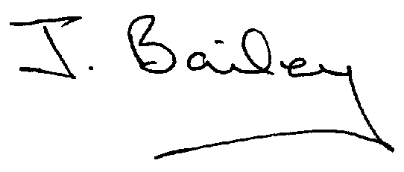Agenda
- Apologies
- Co-option to fill a Casual Vacancy
- Election of Vice Chair
- Declaration of Members Interests.
  - Members must ensure that they complete the Declarations of Interest Sheet prior to the start of the meeting and must indicate the action to be taken (i.e. to stay in the meeting, to leave the meeting or to stay in the meeting to make representations and then leave the meeting prior to any consideration or determination of the item)
  - Where a Member indicates that they have a prejudicial interest, but wish to make representations regarding the item before leaving the meeting, those representations must be made under the item Public Participation
The Declarations of Interests will be read out from the Declaration Sheet – Members will be asked to confirm that the record is correct.

- Public Participation. This is for maximum 30 minutes – no person to speak for more than 5 minutes.
- Minutes of the Last Meeting
- Neighbourhood Watch
- Planning Application, Stydd Hall Farm, Agricultural Worker’s Dwelling.
- Planning Application, The Cottage, Hales Green, extension to garage to form first floor and workshop.
- Planning Application, Honeysuckle Farm, Agricultural Worker’s Cottage (resubmission).
- Waste Bin in Yeaveley
- Footpath Issues
- Highways and Flooding Issues
- Parish Plan
- Change of Broker in connection with council insurance.
- Affordable Housing Communication
- Clerk’s Report
- Financial Matters
- Date of the Next Meeting.

