Rodsley & Yeaveley Parish Council
Dear Residents,
A meeting of Rodsley & Yeaveley Parish Council is to be held virtually via ‘Zoom’ on Monday 18th May at 7.30.
If you would like to virtually ‘attend’ please contact me by email at clerkrodsandyeavpc@outlook.com.

Members are asked to complete the Declarations sheet (if appropriate) provided at the meeting. This will be achieved by the clerk on this occasion.
Yours sincerely

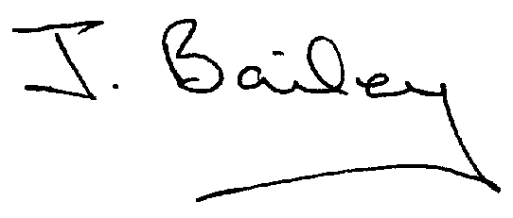Agenda
- Apologies
- Declaration of Members Interests.
  - Members must ensure that they complete the Declarations of Interest Sheet prior to the start of the meeting and must indicate the action to be taken (i.e. to stay in the meeting, to leave the meeting or to stay in the meeting to make representations and then leave the meeting prior to any consideration or determination of the item)
  - Where a Member indicates that they have a prejudicial interest, but wish to make representations regarding the item before leaving the meeting, those representations must be made under the item Public Participation
The Declarations of Interests will be read out from the Declaration Sheet – Members will be asked to confirm that the record is correct.

- Public Participation. This must be kept to a minimum of 5 minutes total
- Minutes of the Last Meeting.
- Co-option of New Councillor
- Election of Chair and Vice Chair
- Temporary Adjustment of Standing Orders to Accommodate Covid 19.
- Neighbourhood Watch
- Complaints re Nuisance Dogs at The Old School House, Yeaveley.
- Planning Application, Stydd Hall Farm, Agricultural Worker’s Dwelling.
- Planning Application, Honeysuckle Farm, Agricultural Worker’s Cottage (resubmission).
- Planning Application 3 to 5 Rodsley Lane, Off Street Parking
- Planning Application, The Pumping Station, Rodsley Lane, Rodsley.
- Planning Application, Brook Cottage, Two Storey Rear Extension and Front Porch. (resubmitted.)
- Planning Application, Westfield House, Hales Green, Extension to Existing Garage to enclose Car Port and Staircase.
- Footpath Issues
- Highways and Flooding Issues
- Clerk’s Report
- Insurance for 2020 to 2021
- Financial Matters
- Date of the Next Meeting.

