Rodsley & Yeaveley Parish Council
Dear Residents,
You are invited to attend a meeting of Rodsley & Yeaveley Parish Council which is to be held virtually via ‘Zoom’ on Monday 13th July at 7.30.
If you wish to attend please contact me at - clerkrodsandyeavpc@outlook.com and I will send you the necessary codes.

Members are asked to complete the Declarations sheet (if appropriate) provided at the meeting. This will be achieved by the clerk on this occasion.
Yours sincerely

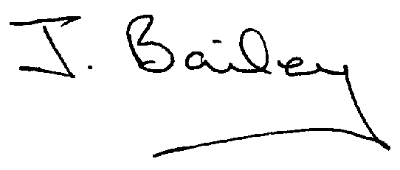Agenda
- Apologies
- Declaration of Members Interests.
  - Members must ensure that they complete the Declarations of Interest Sheet prior to the start of the meeting and must indicate the action to be taken (i.e. to stay in the meeting, to leave the meeting or to stay in the meeting to make representations and then leave the meeting prior to any consideration or determination of the item)
  - Where a Member indicates that they have a prejudicial interest, but wish to make representations regarding the item before leaving the meeting, those representations must be made under the item Public Participation
The Declarations of Interests will be read out from the Declaration Sheet – Members will be asked to confirm that the record is correct.

- Public Participation. This must be kept to a minimum of 5 minutes total
- Minutes of the Last Meeting.
- Neighbourhood Watch
- Complaints re Nuisance Dogs at The Old School House, Yeaveley.
- Planning Application, Stydd Hall Farm, Agricultural Worker’s Dwelling.
- Planning Application, Honeysuckle Farm, Agricultural Worker’s Cottage (resubmission).
- Planning Application 3 to 5 Rodsley Lane, Off Street Parking
- Planning Application, Westfield House, Hales Green, Extension to Existing Garage to enclose Car Port and Staircase.
- Footpath Issues
- Highways and Flooding Issues
- Clerk’s Report
- Audit – Approval and Signing of Certificate of Exemption
- Audit – Approval and Signing of Annual Governance Statement
- Audit – Approval and Signing of Accounting Statement.
- Website Accessibility Requirements.
- Should the Telephone Box ‘Library’ be released.
- Financial Matters
- Date of the Next Meeting.

