Rodsley & Yeaveley Parish Council
Dear Councillors,
You are summoned to attend the Extraordinary Meeting of Rodsley & Yeaveley Parish Council to be via ‘Zoom’ on Monday August 10th at 7.30. Members are asked to complete the Declarations sheet (if appropriate) provided before the meeting.
Yours sincerely

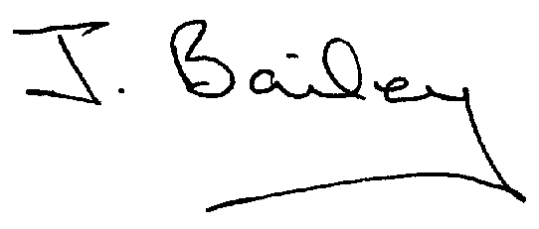Agenda
- Apologies
- Declaration of Members Interests.
  - Members must ensure that they complete the Declarations of Interest Sheet prior to the start of the meeting and must indicate the action to be taken (i.e. to stay in the meeting, to leave the meeting or to stay in the meeting to make representations and then leave the meeting prior to any consideration or determination of the item)
  - Where a Member indicates that they have a prejudicial interest, but wish to make representations regarding the item before leaving the meeting, those representations must be made under the item Public Participation
The Declarations of Interests will be read out from the Declaration Sheet – Members will be asked to confirm that the record is correct.

- Public Participation. This is for maximum 10 minutes – no person to speak for more than 2 minutes.

- Planning Application for the Proposed Replacement Dwelling and Garage Building at Carr Wood House, Rodsley Lane, Yeaveley.

